Lesson 2 Homework  FRONT PAGE | LT 4.2 | 3, 5-10, 21 (draw picture) FRONT PAGE  1-7, 16, 17, 24, 26 (draw a picture & make markings for all problems) BACK PAGE

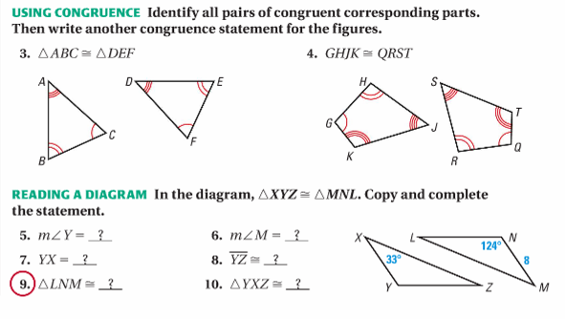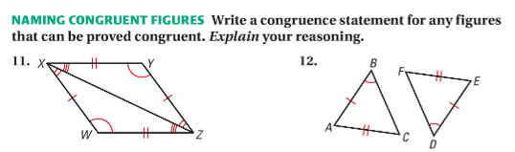
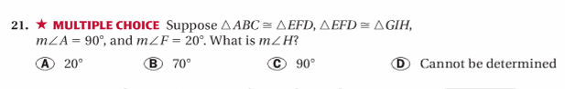

Lesson 2 Homework  BACK PAGE | LT 4.2 | 3, 5-10, 21 (draw picture) FRONT PAGE  1-7, 16, 17, 24, 26 (draw a picture & make markings for all problems) BACK PAGE

